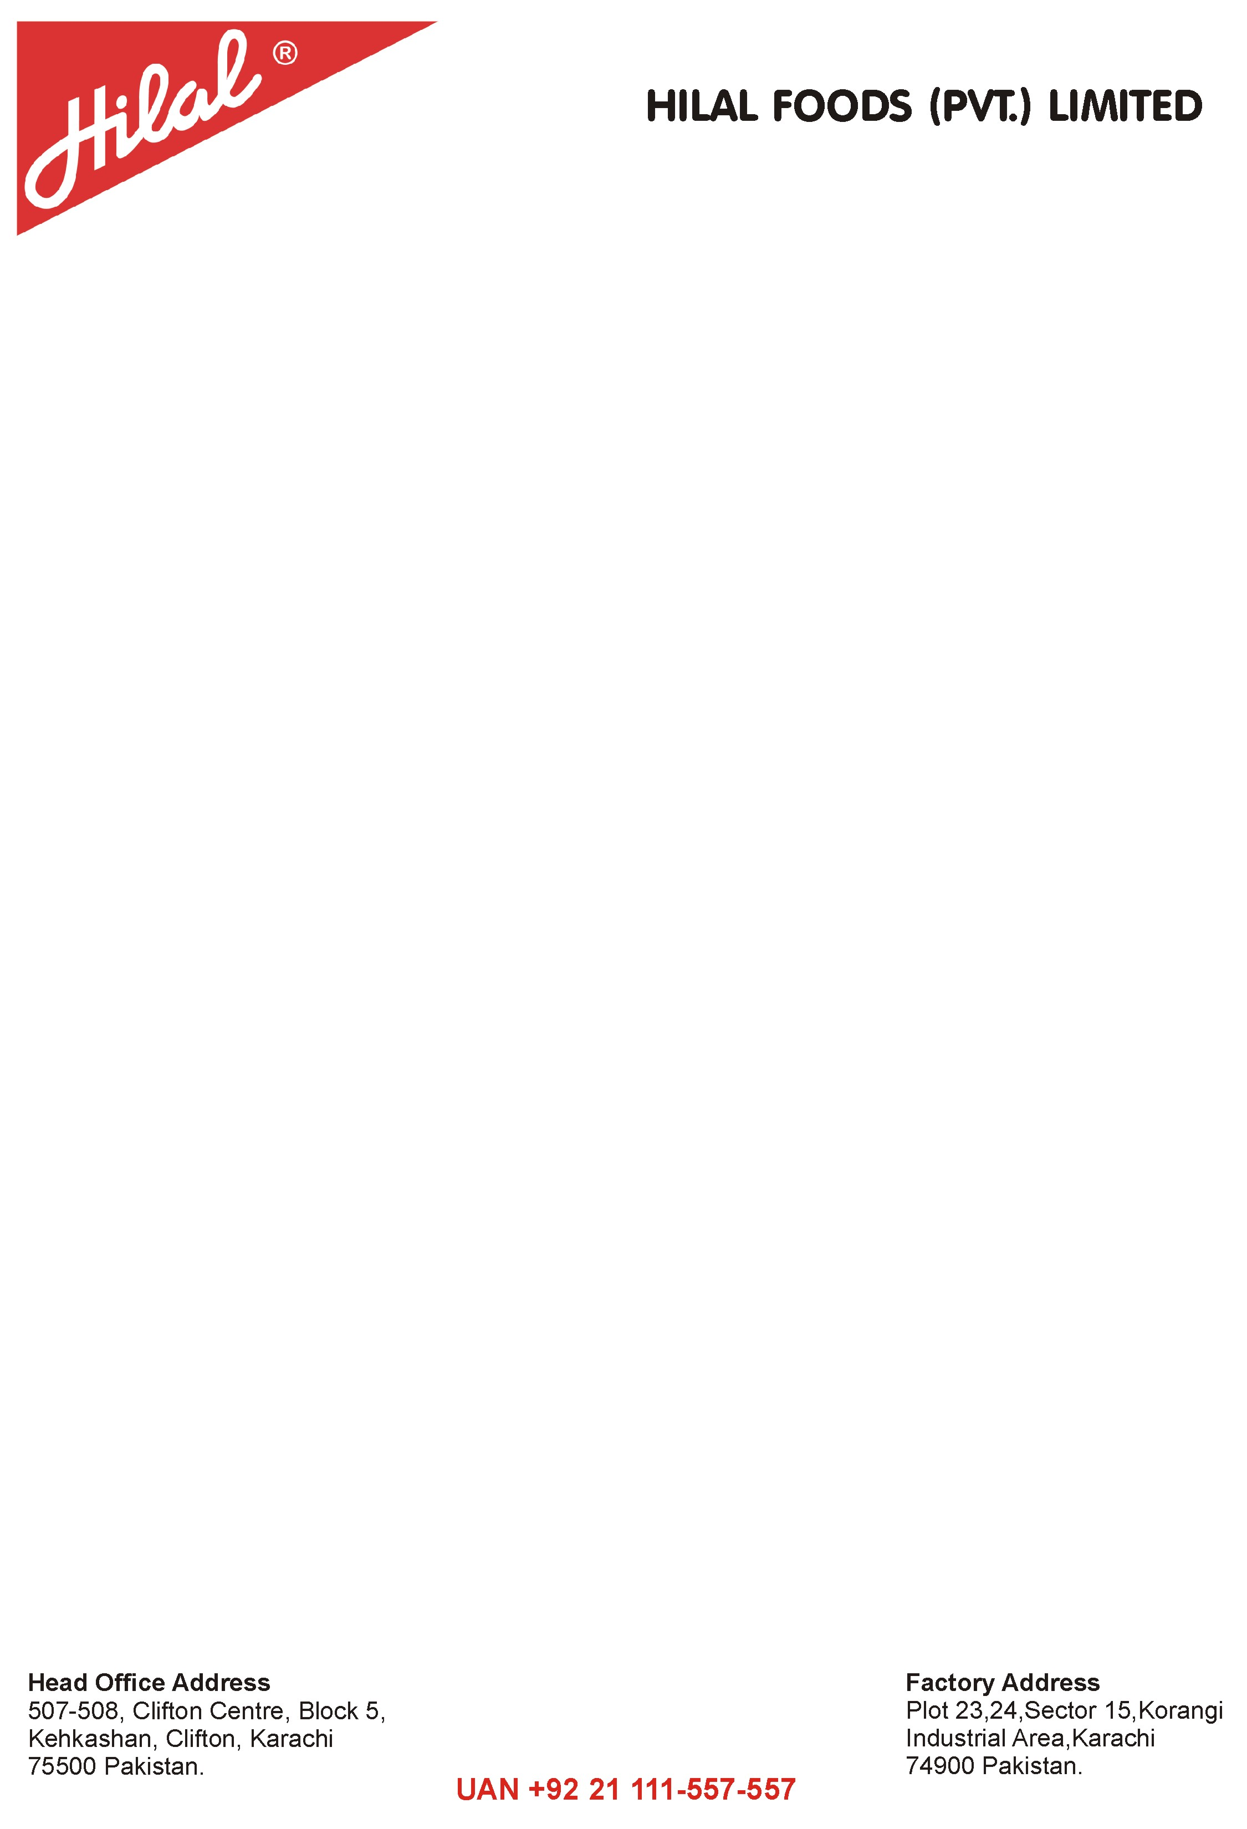

Ref No: 8049-MD Dated:<To2>

**TO WHOM IT MAY CONCERN**

This is certify that Mr. <Name> S/O <fname>, has been working with us as a <Designation> for our factory site Hilal Foods (Pvt.) Limited from <From2> to <To2>.

During his tenure with us we found him very sincere, dedicated and hardworking.

He is still working in this company. This certificate issued on his own demand.

We wish him all the best for his future achievements

**ADMIN MANAGER**